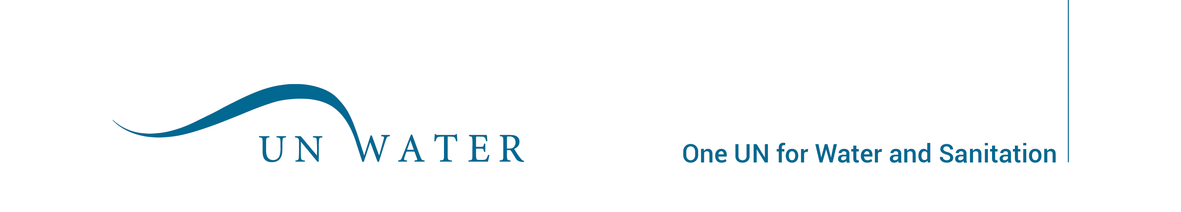
UN-Water
Partnership Form

1. Name and address of organization:

2. Brief corporate history:

3. Brief information on the governance of the organization:

4. How do you see your mandates and objectives in line with those of UN-Water?

5. Which areas of UN-Water Work Programme are you most interested in?

6. How do you see your organization contributing to UN-Water activities?

7. Provide a brief description of current major water related activities your organization is engaged in and which you feel would be relevant for UN-Water.

8. Provide reference letters from two UN-Water Members and fill out the table below with the contact details of one representative of each:

Name | Title | Email | Address

Certification: It is certified that we have read the conditions for partnership criteria stipulated in this document and UN-Water Operational Guidelines. We agree to abide by the procedures and conditions indicated in the above document, and we understand that failing to meet these conditions could lead to termination of our partnership status with UN-Water.

Signed and sealed:

Date:

Please submit this form by email to: UN-Water Secretary, unwater@un.org.
Mailing address: UN-Water Secretary, c/o UN-Water Technical Advisory Unit, 7bis Av. de la Paix, CH-1211 Geneva, Switzerland

