* 1. **DFQ Application Form. -** <https://docs.google.com/document/d/1FdkQw0qyFIkQDT9NiE0qEWdKE2XbcRyV/edit>

**Confirmation Email**

Thank you for your interest in applying for the Dynamic Futures Qatar (DFQ) Scholarship. The Admission and Registration Department team will review your application and contact you with regards to your eligibility for the scholarship.

Best regards,

Admissions and Registration Department

College of the North Atlantic - QatarUniversity of Doha for Science and Technology

**Will the students submit the application forms online?**

This scholarship should only be open for application for first-year students who are accepted and enrolled in the Fall semester in credit programs. The application should only be open as per the dates agreed with EAA. – We should have option to open or close this form and also to inform that these are for first year students

**2. Student Club Membership Registration**

Please do complete the Membership Application Form below:

* Membership form: New / Renewal
* Academic Year* (a dropdown box)
* Club Name* (a drop box)

1. Art Club
2. Four Paws Club
3. Filmmakers Club
4. Qatari Student Association
5. Volunteer Club
6. Cooking Club
7. Music Club
8. Deen Club
9. Best Buddies Club
10. Art Club
11. Toastmasters’ Club
12. Debate Club
13. Photography Club
14. Environment Club
15. Book Club
16. Theatre Club

* First Name* / Last Name*
* E-mail*
* Phone Number*
* Nationality*
* Gender*

**Membership Terms**

* To be a regular student at Doha University.
* It's not allowed to register in more than two different clubs

(box ) I have read, understood, and accepted the rules for membership.

**The thanks msg after the registering**

Thank you for registering. Get ready for a memorable semester!

Please Keep an eye on your inbox for follow-up communication regarding the club classes and activities.

**3.Student Club Membership Registration**

**Student Details**

* First Name / Last Name*
* Academic Year* (a drop box)
* Student Number*
* Email*
* Staff Club Mentor* (A club leader may ask any UDST university staff member or instructor to mentor their club. Please get their agreement before including them in this application.)

| **Name** | **Position** | **Email** |  |
| --- | --- | --- | --- |

**Club details**

* Club Name*
* General Description & Rationale for the Club*
* Club Objective*(Briefly describe your club's purpose, goals, events and activities. What personal growth and/or life experiences can students gain from your club?

Club's Purpose and Goals:

Club's Events and Activities:

What will UDST students gain from this club:

* List club members. * (You must have minimum 10 club members and 2 student lead to start a new club.)

Student lead 2

Student name Student number

Club members

Student name Student number

(10 boxes)

* Club Meeting Day(s) *
  + Monday
  + Tuesday
  + Wednesday
  + Thursday
  + Friday
  + Saturday
* Club Meeting Time*

Hours / Minutes / AM/PM

* Do you need a meeting room on campus?*

Yes No

* Budget Request (Leave empty if you don't need funding from Student Engagement or your budget is not ready yet.)

**The thanks msg after the registering**

Thank you for registering. Our Student Life Coordinator will get back to you with next steps.

**4.Student Club Membership Registration**

• Club Name* (a drop box)

1. Art Club
2. Four Paws Club
3. Filmmakers Club
4. Qatari Student Association
5. Volunteer Club
6. Cooking Club
7. Music Club
8. Deen Club
9. Best Buddies Club
10. Art Club
11. Toastmasters’ Club
12. Debate Club
13. Photography Club
14. Environment Club
15. Book Club
16. Theatre Club

* Academic Year* (a drop box)
* First Name* / Last Name*
* E-mail*
* Phone Number*
* Nationality*
* Gender*
* Why are you interested in being a Club Leader for this region?
* What is your greatest accomplishment / achievements /skills.
* Please provide a list of your ideas for the club’s weekly activities.
* Please provide a list of your ideas for Club events.

**Please read carefully and sign to confirm your commitment**

(box) I understand the commitment and expectations of being a UDST Club Leader. By signing this document, I agree to perform the stated requirements to the best of my abilities. If unable to fulfill my responsibilities I agree to notify the Student Life Specialist staff immediately so that a replacement may be found.

**The thanks msg after the registering**

Thank you for registering. Our Student Life Coordinator will get back to you with next steps.

**5.Testing Center - Get in Touch/Contact Form.**

The following fields to be included in the Contact Us form:

* Name: First and Last
* Email address
* Qatar ID
* Type of Inquiry – IELTS/Placement Tests/Proctoring/Other
* What can we help you with?  Results/Fees/Test Dates/Other
* Type your message here:  __________________
* Submit button

**Confirmation Email**

Thank you for getting in touch with the Testing Center at UDST. Our team will review your query and contact you.

**6.IE Contact Us form.**

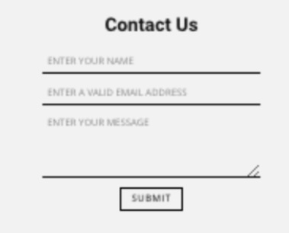

**Confirmation Email**

Thank you for contacting Institutional Excellence Directorate at UDST. Our team will review your query and contact you.

**7.Sport and Wellness Contact Us form.**



**Confirmation Email**

Thank you for your interest in Sport and Wellness at UDST. The Sport and Wellness Department team will review your query and contact you.

**8.CPE Contact Us form.**

* Name: First and Last
* Email address
* Type your message here:  __________________
* Are you interested in subscribing to our newsletter? – Yes / No

**Confirmation Email**

Thank you for your interest in Continuing Professional Education at UDST. Our team will review your query and contact you.

**9.Request for Information form.**

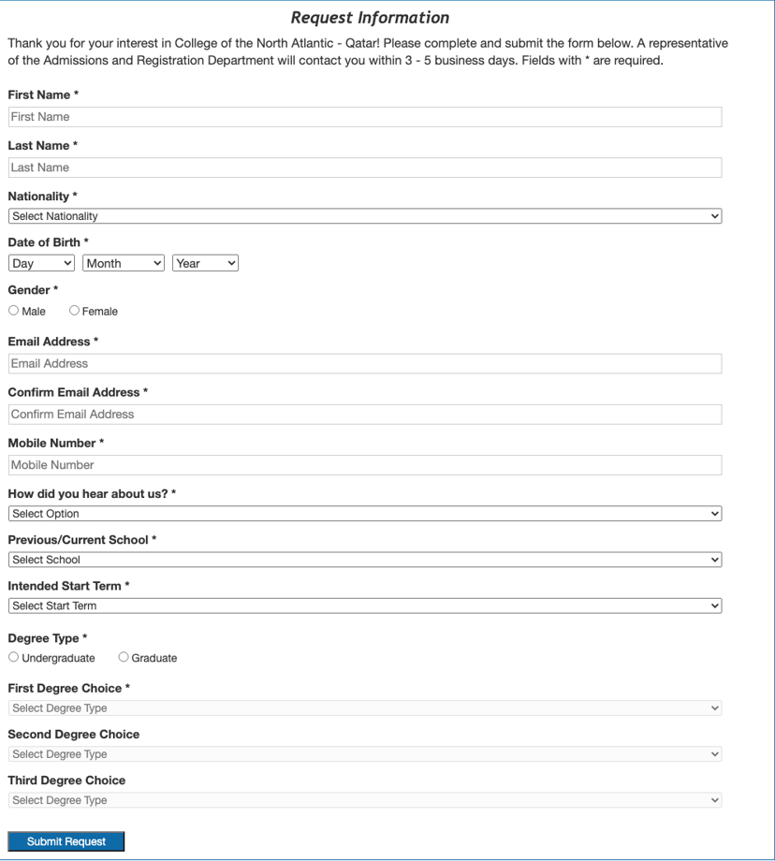

How did you hear about us dropdown list options?

* Family
* Friends
* Social Media
* UDST Graduate
* Others

If **Degree Type** is GRADUATE, then drop down for the following fields is

First Degree Choice

Second Degree Choice

Third Degree Choice

* Master of Science in Accounting and Finance (M.Sc. AF)
* Master of Applied Science in Diabetes Care and Patient Education (M.A.Sc. DCPE)
* Master of Applied Science in Critical Care Paramedicine (M.A.Sc. CCP)
* Master of Applied Science in Human Resource Management

If **Degree Type** is UNDERGRADUATE, then drop down for the following fields is

First Degree Choice

Second Degree Choice

Third Degree Choice

* Bachelor of Applied Science in Digital Communication and Media Production (B.ASc. DCMP)
* Bachelor of Science in Applied Electrical Power and Renewable Energy Engineering (B.Sc.EE EPRE)
* Bachelor of Science in Applied Automation and Control Systems Engineering (B.Sc.EE ACSE)
* Bachelor of Science in Construction Engineering (B.Sc. CE)
* Bachelor of Applied Science in Dental Hygiene (B.A.Sc. DH)
* Bachelor of Applied Science in Environmental Health (B.A.Sc. EH)
* Bachelor of Applied Science in Medical Radiography (B.A.Sc. MR)
* Bachelor of Applied Science in Occupational Health, Safety, and Environment (B.A.Sc. OHSE)
* Bachelor of Applied Science in Paramedicine (B.A.Sc. P) Four Years Bachelor
* Bachelor of Applied Science in Respiratory Therapy (B.A.Sc. RT)
* Bachelor of Science in Applied Chemical and Processing Engineering (B.Sc.A. CPE)
* Bachelor of Applied Business Administration in Applied Accounting (B.A.BA A. Acct)
* Bachelor of Science in Applied Telecommunications and Network Engineering (B.Sc. A. TNE)
* Bachelor of Applied Business Administration in Digital Marketing
* Bachelor of Applied Business Administration in Human Resources Management (B.A.BA HRM)
* Bachelor of Applied Business Administration in Banking and Financial Technology
* Bachelor of Applied Business Administration in Healthcare Management
* Bachelor of Applied Science in Information Technology (B.A.Sc. IT)
* Bachelor of Applied Science in Information Systems (B.A. Sc. IS)
* Bachelor of Applied Science in Data Science and Artificial Intelligence (B.A.Sc. DSAI)
* Bachelor of Applied Science in Pharmacy Technology (B.A.Sc. PT)
* Bachelor of Applied Science in Data and Cyber Security (B.A.Sc. DCS)
* Bachelor of Science in Mechanical Engineering/Applied Maintenance Engineering (B.Sc. A. M)
* Advanced Diploma in Construction Engineering Technology (AD CET)
* Advanced Diploma in Electrical Power and Renewable Energy Engineering Technology (Adv EPREET)
* Advanced Diploma in Automation and Control Engineering Technology (Ad Dip ACET)
* Advanced Diploma in Maintenance Engineering Technology (ADIP MET)
* Advanced Diploma in Chemical and Processing Engineering Technology (ADip. CPE)
* Advanced Diploma in Telecommunications and Network Engineering Technology
* Diploma in Practical Nursing (Dip. Pn)
* Diploma in Automation and Control Engineering Technology (Dip ACET)
* Diploma in Electrical Power Engineering Technology (Dip EPET)
* Diploma in Construction Engineering Technology (Dip CET)
* Diploma in Dental Hygiene (Dip. DH)
* Diploma in Environmental Health (Dip. EH)
* Diploma in Occupational Health, Safety and Environment
* Diploma in Paramedicine (Dip. P)
* Diploma in Respiratory Therapy (Dip. RT)
* Diploma in Healthcare Management
* Diploma in Chemical and Processing Engineering Technology (DIP. CPE)
* Diploma in Telecommunications and Network Engineering Technology (Dip. TNE)
* Diploma in Mechanical Engineering Technology (Dip. MET)
* Diploma in Human Resources Management
* Diploma in Pharmacy Technician (Dip. PT)
* Diploma in Information Technology (Dip. IT)
* Diploma in Information Systems (Dip. IS)
* Diploma in Data Science and Artificial Intelligence (Dip. DSAI)
* Diploma in Digital Marketing
* Diploma in Data and Cyber Security (Dip. DCS)
* Diploma in Applied Accounting

If **Degree Type** is OTHERS, then drop down for the following fields is

First Degree Choice

Second Degree Choice

Third Degree Choice

* Technician Certificate Foundation Program
* Global Awareness and Regional Challenges
* Social Sciences, Humanities and the Arts
* Research Methods and Quantitative Analysis
* Mathematics and Natural Sciences
* English Communication
* Effective & Experiential Learning
* Technician Certificate – Electrical*
* Automated Test Equipment Maintenance
* Electro-Mechanic Operation and Maintenance Technician
* Electronics and Telecommunications Systems Technician
* Technician Certificate – Process Operations
* Technician Certificate – Mechanical
* Technician Certificate – Instrumentation*
* Foundation Program

**Confirmation Email**

Thank you for your interest in University of Doha for Science and Technology. Our team will review your query and contact you.

**All forms should send emails to the owner of the form about new submissions**