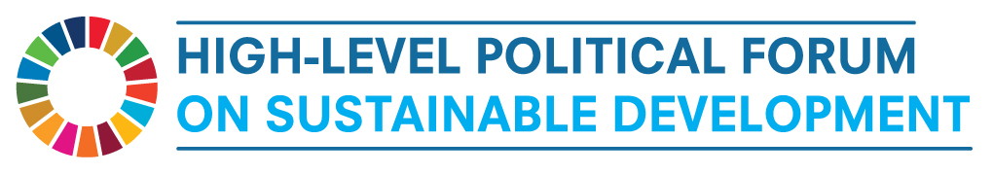
SIDE EVENT

Water Education as the vehicle to achieve SDG 6A

Monday 9 July 2018
18h30-20h00
Conference Room 9, UN Conference Building
Organisers:
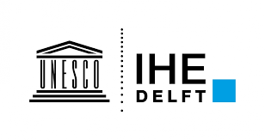
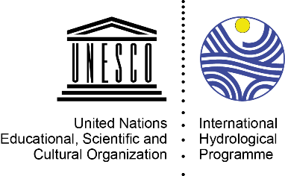

Co-organisers:
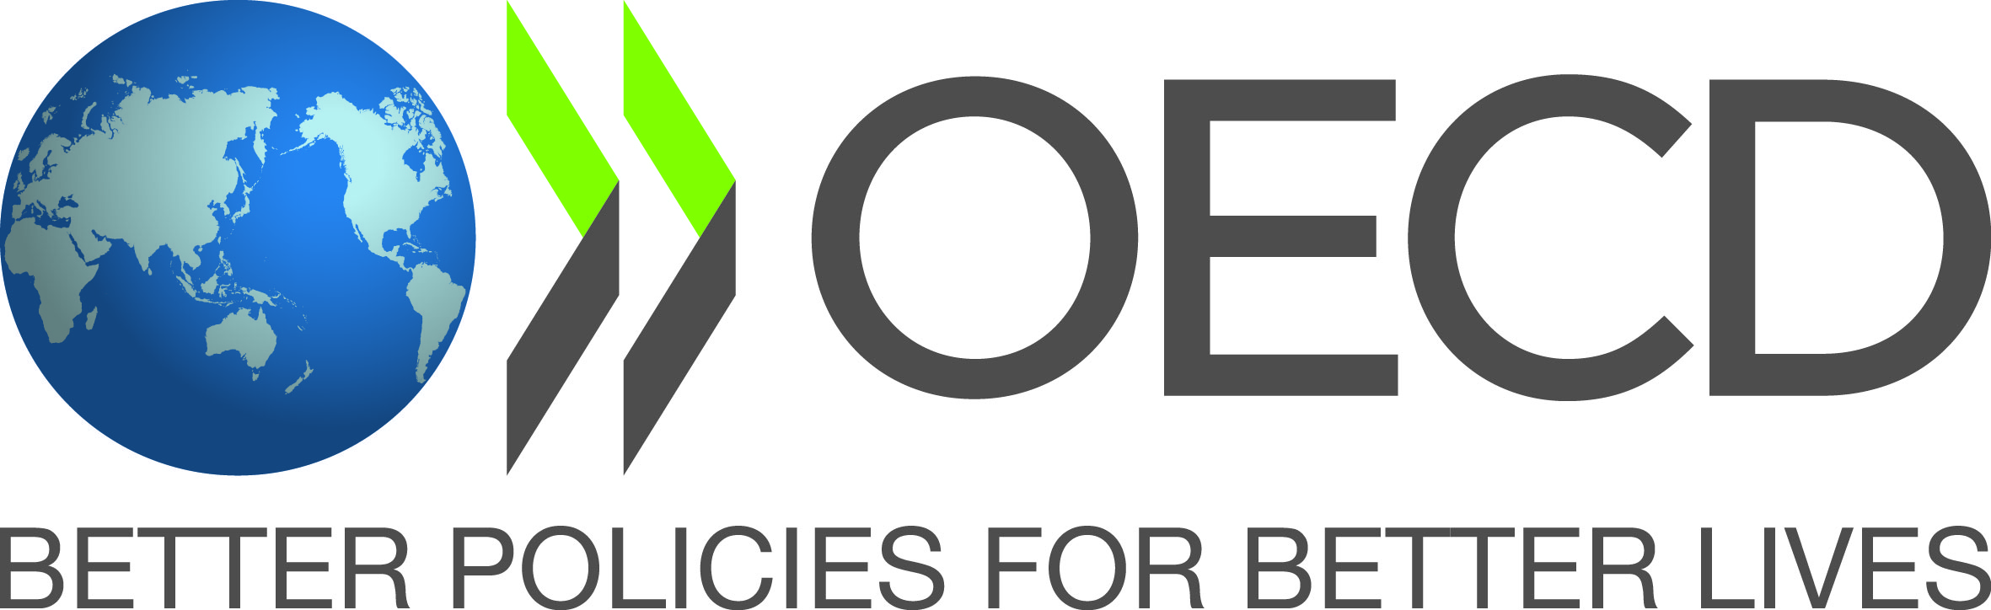

Supporting Countries:
Senegal
El Salvador

The provision of education on water-related issues at all levels and for all, is essential to reach water security and sustainable development. SDG target 6A references the need to expand capacity-building support for water- and sanitation-related activities. This entails the promotion of Water Education and Capacity Building transdisciplinary approaches and the provision of the required knowledge, skills and values. However, a clear status of water education in many countries is not available yet, nor the understanding whether there are sufficiently well-trained staff to study, assess, govern, plan, operate, manage, use, develop and maintain freshwater systems.
The side event will discuss the following questions:
- How to assess whether the water related curricula are adapted to the needs of the new generation?
- How can we increase investments in education?
- How to close the gap between supply and demand of education?
- How to stimulate capacity building for the achievement of the SDG6?
- How can better monitoring of capacity-building help to support sustainable development in the water sector?
SPEAKERS
- Mr Thierno Hamet Baba Ly, Chairperson, International Hydrological Programme (Chair)
- H.E. Ambassador Ruben Hasbún, Permanent Representative of El Salvador at the UN, New York
- Ms. Blanca Jimenez-Cisneros, Director, Division of Water Sciences, IHP
- Mr. Eddy Moors, Rector, IHE Delft, Institute for Water Education
- Ms Aziza Akhmouch, Head of Division of Cities, Urban Policies and Sustainable Development OECD.

