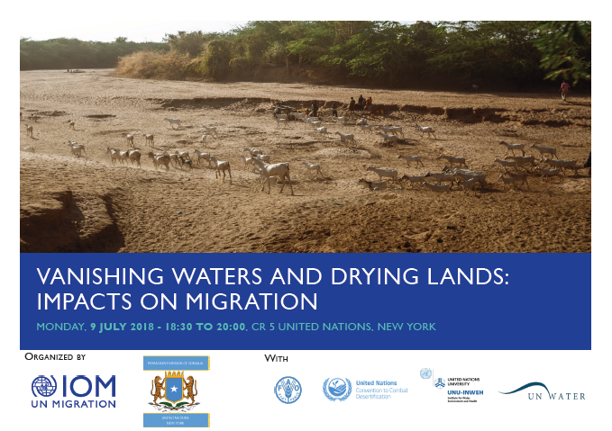

High-level Political Forum (HLPF)
Side Event
Vanishing Waters and Drying Lands: Impacts on Migration

06:30pm – 08:30pm, 9 July 2018, Conference Room 5, UN Conference Building, UNHQ, New York
Organizer: International Organization for Migration (IOM)
Sponsor: Permanent Mission of the Somali Republic to the United Nations, New York
Co-Organizers: Food and Agriculture Organization of the United Nations (FAO), United Nations Convention to Combat Desertification (UNCCD), United Nations University- Institute for Water, Environment and Health (UNU-INWEH), UN-Water

- Background
Migration is a global phenomenon and a defining feature of our times, with millions of people migrating internally and across borders each year. The adverse impacts of climate change and environmental degradation on the availability of natural resources and traditional means of livelihoods are acknowledged as important drivers of migration in our contemporary world. Conversely, migration movements can also impact environmental conditions in places of settlement. There is currently a strong global policy interest on issues of climate change, environment and
migration, notably within the ongoing United Nations negotiations on the Global Compact for Safe, Orderly and Regular Migration and in the work undertaken on the climate change - migration nexus under the United Nations Framework Convention on Climate Change (UNFCCC).
- Event description
This event will focus on two dimensions of the migration, environment and climate change nexus, bringing together two of the Sustainable Development Goals (SDGs) under discussion at the 2018 High Level Political Forum (HLPF): water (SDG6) and land (SDG15).

The impacts of climate change on both water and land availability are acting as major drivers of migration. Water is estimated to be one of the resources most affected by climate change and recurrent variations in water availability and prolonged water insecurity can have significant implications for human mobility. For example, in 2017 IOM estimated that more than 475, 000 people in Ethiopia and over 1.2 million people in Somalia were displaced due to drought. When faced with water insecurity, vulnerable populations often use migration as a risk management strategy, which highlights the important connection existing between water-related environmental factors and migration flows. The theme of World Water Day 2019 is “leaving no one behind”, and this means also considering the impact of water on migration and human rights.

Land degradation and migration are also interconnected. Land degradation is defined as the reduction or loss of the biological or economic productivity and complexity of land. Higher temperatures and changes in precipitation patterns associated with climate change are significantly affecting the process of land degradation. Since in most developing countries people depend primarily on land for their sustenance, land degradation is consequently eroding traditional livelihood options and forcing people to leave in search for better opportunities.

This side-event will therefore address the important connections existing between water, land and human mobility in the context of climate change and explore how sustainable water and land management can enhance the resilience of affected populations and help avoid instances of forced migration. Providing people with secure and equal access to land, water and natural resources can also play a key role in facilitating sustainable water and land management. Property rights to these resources can in fact provide communities and individuals with a powerful incentive to enhance natural resource management and invest in mitigation and adaptation measures.

- Objectives of the event
This event seeks to identify the linkages between water, land and migration and explore potential policy responses under the SDGs framework. Through Goal 6 on sustainable management of water and sanitation and Goal 15 on protecting and restoring life on land, the SDGs have laid down an important foundation for addressing the key linkages between climate change-induced migration, land and water. The event will also offer an opportunity to explore how we can break existing silos and find possible synergies across the migration, water and land governance frameworks.

- Programme Details

Welcome Remarks and Keynote Speech (10 min):
Ambassador Abukar Dahir Osman, Permanent Representative, Permanent Mission of the Somali Republic to the United Nations, New York

Welcome remarks and moderation (10 min):
Ambassador William Lacy Swing, Director General, International Organization for Migration (IOM)

Panel Discussion (10 minutes per panelist):
Food and Agriculture Organization of the United Nations (FAO)
United Nations University-Institute for Water, Environment and Health (UNU-INWEH)
United Nations Convention to Combat Desertification (UNCCD)

Questions and Answers Session (30 min)

Concluding Notes (10 min)

- Contact Details

For further information, please contact:
Mariam Traore Chazalnoel
Thematic Specialist
Migration, Environment and Climate Change
IOM New York
mchazalnoel@iom.int

UNGA (2012). Resolution adopted by the General Assembly. The future we want. Res. 66/288, 11 September 2012.
World Bank (2006), Sustainable Land Management: Challenges, Opportunities, and Trade-offs. Agriculture and Rural Development.

